CSE 102 Practice Problems on Branching

1. Write a C program which takes a character as input and outputs whether the character is alphabet, digit or a special character.
2. Write a C program to find the greatest of four integers.
3. A triangle is enclosed by three vertices A, B, C as showed in the following figure. Write a C program which takes input the three vertices and outputs whether the triangle is a valid one or not.

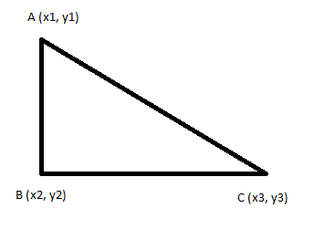

1. Write a C program to input electricity unit charges and calculate total electricity bill according to the given condition:

* For first 50 units Tk. 0.50/unit
* For next 100 units Tk. 0.75/unit
* For next 100 units Tk. 1.20/unit
* For unit above 250 Tk. 1.50/unit
* An additional surcharge of 20% is added to the bill

1. Given a year as input, write a C program to find the closest leap year. For example, If the input year is 1997, the closest leap year should be 1996.